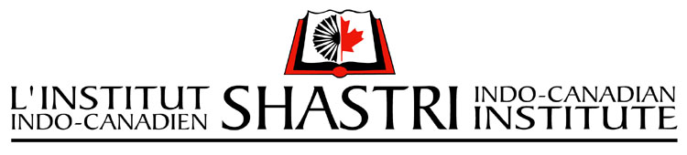

Shastri Bilateral Education Summit (SBES) 2025
Bridging Borders: Sustainable Partnerships through Indo-Canadian Academic Synergies

SBES Subsidy Grant 2025

Application Form for Indian Participant

Email your completed application package to anjut@sici.org.in

1 | APPLICANT  Name:  Designation (Prof/Associate Prof/Assistant Prof/Other):  Home Institution:  Email:  Cell Phone #:
2 | Are you a full-time Faculty Member? Yes No
3 | Are you an Indian Citizen? Yes No
4 | Please indicate your gender  I prefer not to answer
5 | Do you hold Scheduled Caste status as designated under Article 341 of the Constitution of India, 1949?  Yes ; No ; I do not wish to answer ; Not applicable  If yes, please specify: I do not wish to answer  Do you hold a Scheduled Tribe Status as designated under Article 342 of the Constitution of India 1949?  Yes ; No ; I do not wish to answer ; Not applicable  If yes, please specify: I do not wish to answer  Please indicate if you hold an Other Backward Class (OBC) Status  Yes No I do not wish to answer Not applicable  If yes, please specify: I do not wish to answer  Note: Applicants who are from SC/ST/OBC category are required to attach a pdf copy of original community certificate issued by competent authority with the application.
6 | Please submit a single PDF containing the following sections in sequential order and email it to anjut@sici.org.in  - Application Form for Indian Faculty  - Participation Detail Form  - Curriculum Vitae (3 pages max.)  - Copy of original community certificate (for applicants from SC/ST/OBC category)
Signature of the Applicant |  | Date

