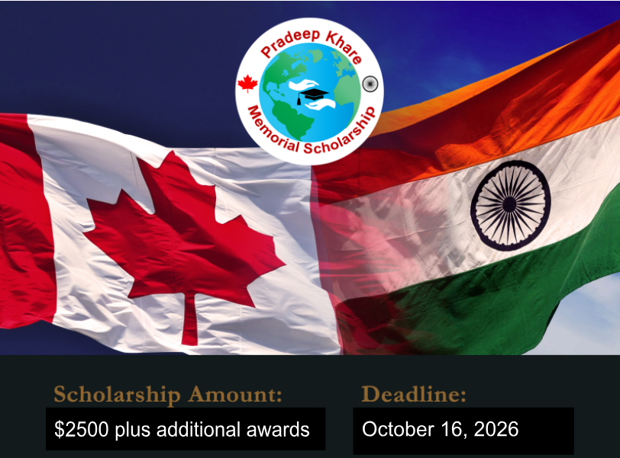

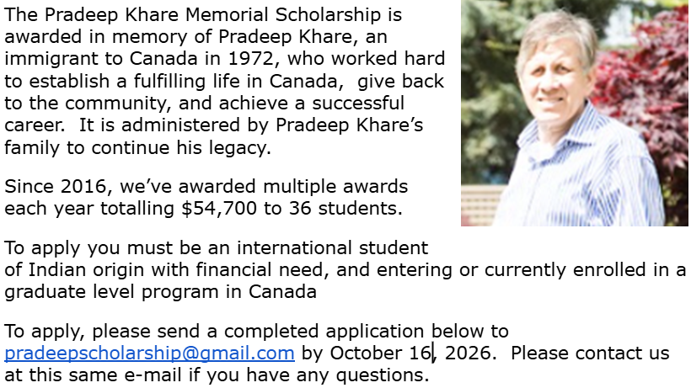

PRADEEP KHARE MEMORIAL SCHOLARSHIP
APPLICATION FORM
2026

APPLICANT PERSONAL INFORMATION:

Applicant Last Name: ____________________________ First Name: _______________________________

Address: ________________________________________________________________________________________

City, State/Province: _______________________________________ Country: ________________________

Telephone: __________________________________ E-mail: __________________________________________

Date of Birth (mm/dd/yyyy): ______________________________

APPLICANT EDUCATIONAL INFORMATION:

- List all educational institutions attended for undergraduate or previous graduate work, years attended, and program of study.

Institution: _________________________________________________________________________________

Dates Attended: ____________ - ____________ Program of Study: ___________________________

Institution: _________________________________________________________________________________

Dates Attended: ___________ - _____________ Program of Study: ___________________________

Institution: _________________________________________________________________________________

Dates Attended: ___________ - _____________ Program of Study: ___________________________

- Are you currently enrolled in a Canadian university for graduate work?

Yes _____ No _____

- If yes, in which Canadian University are you currently enrolled?

__________________________________________________ Program: _____________________________

Program Start Date: _____________ Expected Program End Date: ______________

- If no, which Canadian University are you hoping to attend in Fall 2026?

__________________________________________________ Program: _____________________________

Have you received an acceptance from this university? Yes ______ No _______

If yes, have you accepted the offer? Yes ________ No _________
Where did you learn about this scholarship opportunity? ___________________________________________

FINANCIAL INFORMATION:

Describe to us your financial need. You can use the following questions as a guideline, but please include any additional information you feel is pertinent to your financial need. (Length: no more than 1 page).
- How have you paid for your education thus far, and how will you be paying for your future education?
- Are you employed, or do you plan to be employed during the school year?
- Do you receive any financial support from loans, scholarships, family, or other sources?
- How will you use this scholarship and how will this scholarship enable you to achieve your goals?

ESSAY QUESTIONS:

Please answer each of the following questions.

- Describe your volunteer experience. How have your experiences helping others or helping communities contributed to your personal growth? (400 words)

- What are your educational and/or career goals? How does studying in Canada help you achieve these goals? (400 words)

- How do you plan to incorporate community service, volunteerism, or social accountability in your life? (300 words)

- How has your Indian heritage shaped your values and beliefs? How have you promoted, or will you promote, diversity in your community (school, work, or social)? (400 words)

- What is leadership? How are you a leader? (300 words)

- Is there anything else you would like to share with us? (200 words)

NEXT STEPS FOR APPLICANTS:

1. Please submit this form along with your Curriculum Vitae (page limit: 2 pages excluding publications) by email to pradeepscholarship@gmail.com.

2. Proof of enrollment and official transcripts may be requested if you are selected to move forward with the application process. You will be contacted via e-mail with your application status in late Fall 2026.

INFORMATION: If you have any questions or want more information about the scholarship, please e-mail pradeepscholarship@gmail.com. Thank you for your application.

